Gene-disease relation extraction and gene interaction network construction
Changqin Quan ^{a,}*, Lei Huaª and Fuji Ren ^{a,b}
ª School of Computer and Information, HeFei University of Technology, Tunxi Road No.193
Hefei, 230009, China
^{b} Faculty of Engineering, University of Tokushima, 2-1 Minamijosanjima, Tokushima 770-8506, Japan
Abstract. The relations between gene and disease play an important role in biomedical processes. This paper makes an analysis on existing relation extraction systems, especially on the systems’ capabilities of generalization. After that, a relation extraction method with the combination of parser and rules is proposed, moreover, the method focuses on the visual and analysis of the gene interaction network. The proposed approach uses Stanford parser to analyze the original sentence to construct a dependency directed graph, and then uses the combination of a gene name dictionary and the maximum entropy model to solve the gene name entity recognition problem, DFS (deep first search) algorithm is applied to search the paths between two gene entities from the directed graph, and then to find the interactions between name entities through some pre-defined rules. Finally a gene disease network can be constructed through the extracted relations. Network analysis is applied to get the most relevant gene entities to the disease.
Keywords: Gene-disease relation extraction, gene interaction network, gene entity recognition, network analysis

Introduction
With the rapid growth of information, more biomedical facts can be extracted from literatures. In fact, relation extraction [1] can be considered as a basic problem to understand non-structural data, through the extracted relations, for example, gene disease [2] relations, some hidden facts can be found from these structural data. Some of the existing databases like Online Mendelian Inheritance in Man (OMIM) has built gene relations, and even generated the gene interaction map. However most of the relations in OMIM are manually collected from literatures, therefore, it cannot keep up with the rapid growth of the biomedical data.
In this paper, a relation extraction method is proposed based on the combination of full parsing and rules. The parser is used to analysis the structure of a sentence, especially for the dependency relationship between two words. The pre-defined rules are applied to filter the results. A gene interaction network is constructed on the basis of extracted relations. Through the network analysis, the proposed approach can extract the most relevant gene entities to a specific disease.
The rest of paper is organized as follow. Section 2 surveys the related work for relation extraction. Section 3 introduces the proposed method and processes in detail. Section 4 gives the experiments and results. Moreover, finally in section 5 a short conclusion and future work will be discussed.

Related work
Recently many efforts have been done on relation extraction. Relation extraction system has experienced from relatively simple string handling forms to natural language processing and the application of machine learning algorithms. Relatively simple system [3] uses the co-occurrence of gene entities to extract the relations. However the system still relies on gene (protein) entities’ repeatability in the documents on the basis of such a hypothesis. Consequently, the extracted relations exhibit high sensitivity but very low specific.
Some of the methods use the existing structured relational databases, for example, OMIM, MINT [4], INTACT [5] , BIND [6] etc. Although these organized relational databases contain a lot of manual annotation data, but they also take a lot of manual annotation time and effort, and with the passage of time, then there will be greater relationships with the emergence of a large number of new biological literatures.
Pattern matching-based approaches focus on how to summarize patterns effectively. Ekaterina Buyko [7] summarized the relation extraction methods and proposed thirteen patterns. These patterns include most of the cases of gene interaction. Akane Yakushiji [8] considered the interaction verbs as the patterns classification standard, and they divided the patterns into five kinds of circumstances. However the pattern matching method has a drawback is that due to the diversity of language, makes a good pattern set in advance sometimes cannot sum up the reality of the original documents effectively.
Some complex systems use machine learning [9] algorithms to solve biological entities relation extraction problem. From the perspective of machine learning algorithms, the relationship between biological entities extraction can be considered as a binary classification problem. For this binary classification problem, researchers usually focus on the features extraction. Zhou [10] had made a very detailed exposition. The features were divided into eight parts: words, entity type, mention level, overlap, base phrase chunking, dependency tree, parse tree, and semantic resources. Through extracting these rich features, some existing machine learning algorithms like SVM [11], maximum entropy model [12], kernel method [13] etc. can be used. However, systems based on machine learning algorithms are largely affected by the training data.
With the development of natural language processing technology, more and more natural language processing tools are also emerging, so how to combine natural language processing tools for relation extraction has become a hot spot. The advantage of using natural language processing techniques is that this kind of processing methods can be understood from the perspective of grammatical structure of a sentence, they are different from machine learning algorithms. Machine learning algorithms reflect the capacity of the induction and mostly from the perspective of algebra or statistics to analyze data. However, natural language processing-based approaches more in line with the human way of thinking, the current natural language processing systems achieved relatively good results. Some methods [14-15] used Stanford syntactic analysis tools to analyze sentence structure, and the structure presented in the form of a tree, by searching for the shortest path between entities to extract relations. In addition to the data in the form of a tree structure to show, Jari Björne [16] et al. developed the TEES system, the data was represented in the form of graphs, and organized in XML file format, and then a combination of features and multi-label SVM method was utilized to extract relations.
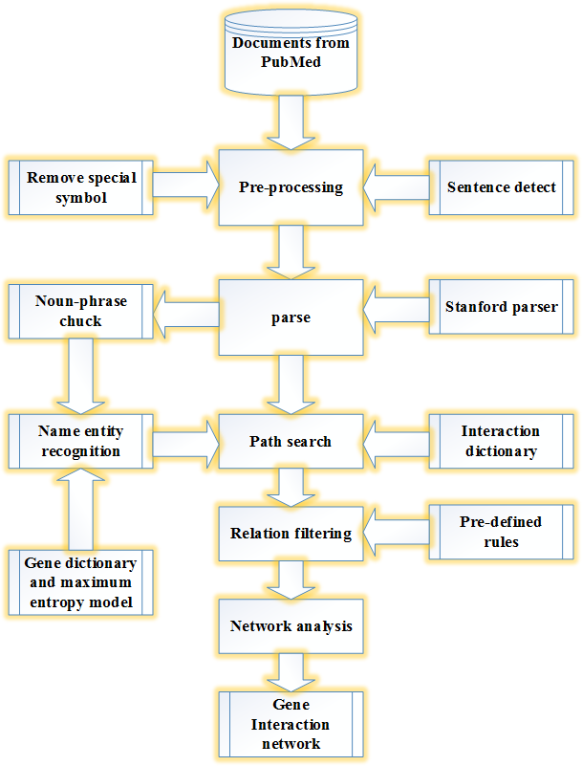
Fig. 1. Architecture of the Gene-disease relation extraction system.

Relation extraction and network analysis

Text pre-processing
Figure 1 shows the architecture of the Gene-disease relation extraction system. The system can extract relations from free-text sentences, and it is domain independent.
Apache axis is used as a server to get about 44706 biological literatures from PubMed database with the keyword “breast cancer gene” since breast cancer is considered as a testing disease in this study. Stanford parser [17-20] is used to detect the sentences, and eventually obtain 181105 sentences.

Full parse tree and noun-phrase chucks detecting
Parse tree is mainly used to analyze the structure of a sentence. Figure 2 gives an example, which is a part of the phrase structure parse tree of the sentence “These results suggest that YfhP may act as a negative regulator for the transcription of yfhQ, yfhR, sspE and yfhP”.
In order to simplify subsequent analysis, the results of the parse tree is used to detect the noun-phrase chucks, noun-phrase chucks can be considered as a single word and the system can ignore the internal relationships of chuck. Then the system travels the full parse tree and finds the node which name is “NP” and the maximum depth is less than 2, circled in red parts in Figure 2 are the noun-phrase chucks the system has detected.
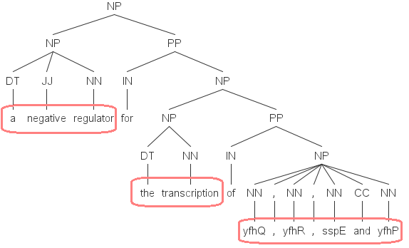
Fig. 2. A part of the phrase structure parse tree of the sentence “These results suggest that YfhP may act as a negative regulator for the transcription of yfhQ, yfhR, sspE and yfhP”.

Dependency parsing
The dependency parse of a sentence captures the semantic relationships among its words. Figure 3 shows the directed graph that constructed from dependency parse. Noticing that the number behind each signal word represents the position of the word in a sentence.

Name entity recognition and interaction verbs detect
The combination of a gene name dictionary and maximum entropy model [21] is utilized to solve the problem of gene name entity recognition. All gene names are crawled from the OMIM database. The problem is that gene name dictionary cannot include all the gene names. Maximum entropy model is used to judge whether a noun is a name entity when this noun is not include in the gene name dictionary. In order to improve accuracy, the system uses a threshold value 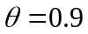 which represents the probability calculated by maximum entropy model of a noun is considered as a gene entity, and the system will consider a noun as name entity if and only if the probability of this noun greater than the threshold. In fact, interaction verbs play an important part in relation extraction, and most of the gene interactions are embodied by interaction verbs. Katrin [14] had built an interaction verbs dictionary, which contained 184 interaction words, and most verbs were associated with biological, like “express”, “inhibit” etc. In this study, the dictionary is used to find the interaction verbs.
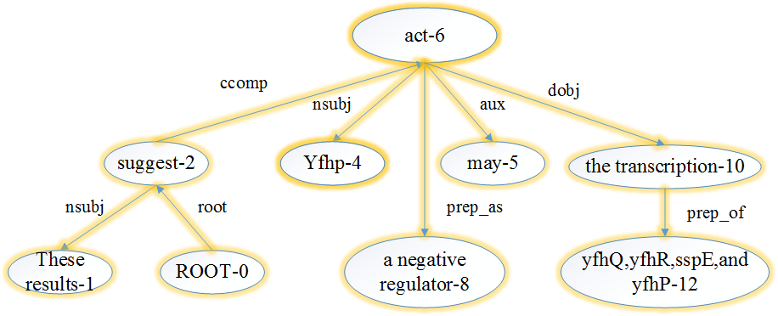
Fig. 3. Direct graph constructed by dependency parser.

Paths searching and relation extraction
Since verbs play an important role in relation extraction, the system consider the extracted interaction verb as a root node and search for the all paths from root node to leaf nodes. Considering the example in Figure 3, taking the interaction verb “act” as a root node, the generated paths are as follows.
Path a: act-6 ---> Yfhp-4
Path b: act-6 ---> a negative regulator-8
Path c: act-6 ---> may-5
Path d: act-6 ---> the transcription-10 ---> yfhQ, yfhR, sspE and yfhP-12
The system mainly focuses on the paths with gene name entities, for example the “Path a” and “Path d”. In this case, a new path will be generated by combing “Path a” and “Path d”, as follow:
Yfhp-4 <--- act-6 ---> the transcription-10 ---> yfhQ, yfhR, sspE and yfhP-12
The interaction pair “Yfhp” and “yfhQ, yfhR, sspE and yfhP” can be extracted in this path.

Relation filtering
Relation filtering mainly includes two aspects: one is to filter the incorrect relations; the other is to determine which is in a dominant position in a relation.
Three rules are pre-defined to filter the incorrect relations:
Rule 1: The position of two name entities in a sentence should be on both sides of an interaction verb. For example in section 3.5, the “Yfhp-4” is on the left of the verb “act-6”, while the “yfhQ, yfhR, sspE and yfhP-12” is on the right of verb “act-6”.
Rule 2: There are not more than three verbs between two entities. There is only a verb “act-6” between gene entities “Yfhp-4” and “yfhQ, yfhR, sspE and yfhP-12”. However, when a path contains three or more verbs between two entities, our system cannot decide to choose which verb as interaction verb, in this situation, this path should be ignored.
Rule 3: A path should not contain any negative word.
Which entity is in a dominant position in relation is mainly judged by interaction verb, the system mainly uses the dependencies of verb. In general, a verb has two kinds of dependencies: “nsubj” and “nsubjpass”. The former one represents the active voice while the latter represents the passive voice. That means if a verb has a dependency of “nusbj”, the entity that position is on the left of interaction is in a dominant position. Otherwise the gene entity right to the interaction verb will in charge of the entity left to the interaction verb.

Special cases
Some special cases should be taken into account:
Special case 1: Not all the relations are generated by interaction verbs but by some prepositions. For example: “the expression of gene_A by gene_B”. gene_A affects gene_B through preposition “by” in this case. The proposed method can collect all pairs of the noun-phrase chucks which have dependencies of preposition and both of chucks are name entities to extract relations.
Special case 2: When there are two interaction verbs between two entities, the system will choose the latter verb as the interaction verb.
Special case 3: Some verbs themselves contain the meaning of passive even they have the dependency of “nsubj”, like “require”, “depend”, “rely”, etc.

Relation network construction and analysis
Considering each gene name entity as a node in a graph, and, a gene interaction network can be constructed by using the extracted gene relations. The method mainly focuses on the analysis of centralities for that the centralities can measure the importance of a node in a network. Moreover, finally, a weight method which combines the degree centrality and betweenness centrality is proposed to measure the importance of a node.

Degree centrality
Degree centrality can measure the central tendency of a node in a network. A node will be more important and contains more energy if more edges are connected to this node. Degree centrality 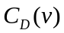 of a node can be calculated as Eq. (1).
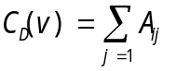 (1)
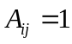 When there is an edge between node and node.

Betweenness centrality
Betweenness centrality reflects the ability of a node to control other nodes, in other words, it measures the ability of a node to take charge of the resources in a network, the more nodes are on the shortest path of other nodes, the more resources these nodes will control. Betweenness centrality 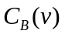 of a node can be calculated as Eq. (2).
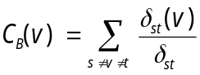 (2)
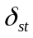 is the sum of shortest path from node to , while 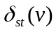 stands for the sum of shortest path from node to node pass through node .

Weighted centrality
In order to better measure the importance of a node in network, the degree centrality and betweenness centrality are weighted, and the following sections will justify this weighted centrality by experiments, the weight centrality 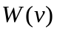 of a node can be calculated as Eq. (3).
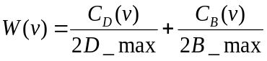 (3)
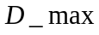 represents the maximum value of all the 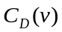, while 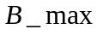 is the largest betweenness centrality among all the nodes.

Test on LLL-challenge standard dataset and the results of network analysis

Test on LLL-challenge dataset
The LLL challenge 2005 task is to learn rules to extract protein/gene interactions from biology abstracts from the Medline bibliography database. We compare the result with other relation extraction system, Table 1 shows the results. In fact, we get pretty good precious but low recall. We more care about the system’ ability of generalization and application of large scale dataset, and in order to enhance the precious, we defined three rules and three special cases, and these rules may filter some right paths, so that our recall becomes lower.
Table 1
Compare with other relation extraction systems
Method | precious | Recall | F-measure
Autopat | 0.58 | 0.63 | 0.60
Rule-based | 0.56 | 0.30 | 0.39
Predicate kernel | 0.71 | 0.72 | 0.72
Dependency kernel | 0.59 | 0.63 | 0.61
Hybird kernel | 0.66 | 0.74 | 0.70
Walk kernel | 0.73 | 0.83 | 0.78
Our system | 0.77 | 0.70 | 0.73

Conducting an error analysis, the usage of public available nature language tools like Stanford parser, maximum entropy model make system more rely on the behavior of these tools. On the other hand, some of errors are caused by system, the errors can be concluded into three aspects:
Cause 1: Some of the errors are caused by co-reference, which has been a common problem in relation extraction. By using the results of dependency parsing, in fact, this problem would be considered for solving in the future work by replacing all the pronouns like “that”, “which” etc. which refer to gene name entities with the gene names because most of co-reference problems occur with a reference chain.
Cause 2: Some of the relations are not interacted by interaction verbs or prepositions, the proposed method do not include these situations.
Cause 3: As the system chose the latter interaction verb when a relation path has two interaction verbs, while the former verb may be in a dominated position sometimes. And many errors were caused by the wrong choices of interaction verbs.

Network analysis

The results of degree and centrality analysis
Degree centrality reflects the centrality trend of a node in a network. The higher degree centrality of a node means the stronger centrality trend and the higher position in the network.
Figure 4 shows the degree centrality of all nodes. There are total 845 nodes in the figure, and each node represents a gene name entity, and the straight lines in figure are the extracted relations among all the gene name entities. On the other hand, the size of each node is measured by the value of degree centrality. In general, the deeper the color, the bigger the degree centrality value is. In order to show it clearly, part of the gene interaction network was enlarged, which could be seen on the upper right corner.
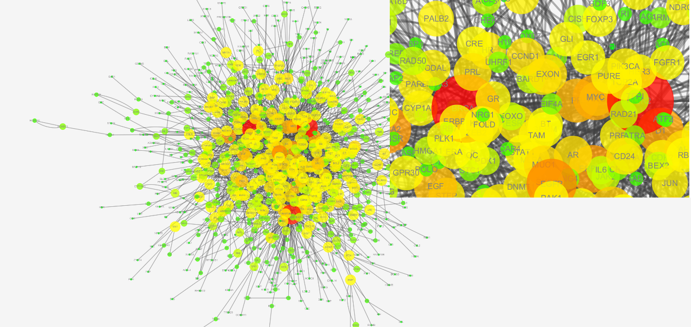
Fig. 4. Network of degree centrality analysis.
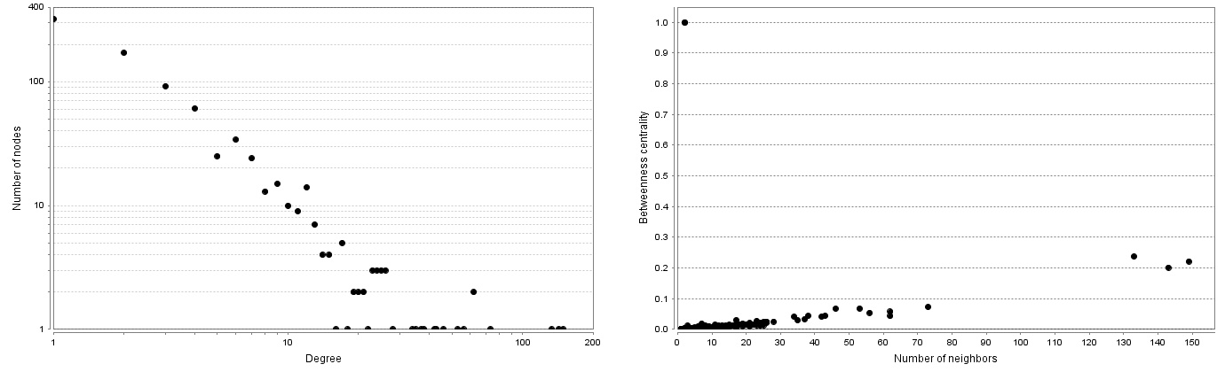
Fig. 5. Distribution of degree centrality and betweenness centrality
The left part in Figure 5 is an overview of distribution of the degree centrality. In fact, a node can be considered as the edge part of a network and has little contribution to the network when the degree centrality of this node is less than 2 in the final analysis. 10 gene entities with highest ranked are selected.
The left part of Table 2 shows the top 10 gene entities which select from the all the 845 nodes. BRAC1 (breast cancer gene 1) and the BRCA2 (breast cancer gene 2) are public recognized as the genes which have significant influence on breast cancer. HER2 (Human epidermal growth factor receptor-2) has already been confirmed that this gene is an oncogene in breast cancer, some laboratories had developed a suitable antibody to against HER2 gene. MB in fact, belongs to the cellular level but is not in gene level, since the system wants to extract all the relevant gene entities to breast cancer, MB is considered as a mistake of system. EGFR (epidermal growth factor receptor) is another gene that related to breast cancer, Lluch A [22] had already described the relationship between EGFR and breast cancer in paper. Omenn Gs [23] had confirmed that ERBB2 (v-erb-b2 avian erythroblastic leukemia viral oncogene homolog 2) would behave on breast cancer. D1 means the cyclin D1 in fact, cyclin D1 is also related to the breast cancer [24]. The rest genes are MYC (v-myc avian myelocytomatosis viral oncogene homolog), VEGF (vascular endothelial growth factor) and PR (progesterone receptor), by referring to some biological literatures, all of these three gene entities can be drawn with breast cancer.

The result of betweenness centrality
Betweenness centrality reflects the ability of a node to control the resources in a network. The network is similar to the result of degree centrality. Figure 6 is the network constructed by the standard of betweenness centrality, each node in circle represents a gene name entity, different size and the color of nodes stand for different values of betweenness centrality.
Table 2
Top 10 gene entities with highest ranking of degree centrality and betweenness centrality
The top 10 gene entities of degree centrality |  |  |  | The top 10 gene entities of betweenness centrality
Gene name | Degree | Relevant |  | Gene name | Betweenness | Relevant
BRAC1 | 149 | YES |  | HOX | 1.0000 | YES
HER2 | 143 | YES |  | SYK | 1.0000 | YES
MB | 133 | NO |  | MB | 0.2370 | NO
EGFR | 73 | YES |  | BRCA1 | 0.2218 | YES
BRCA2 | 62 | YES |  | HER2 | 0.2015 | YES
ERBB2 | 62 | YES |  | EGFR | 0.0759 | YES
D1 | 56 | YES |  | MYC | 0.0683 | YES
MYC | 53 | YES |  | PR | 0.0678 | YES
PR | 46 | YES |  | ERBB2 | 0.0576 | YES
VEGF | 43 | YES |  | D1 | 0.0544 | YES

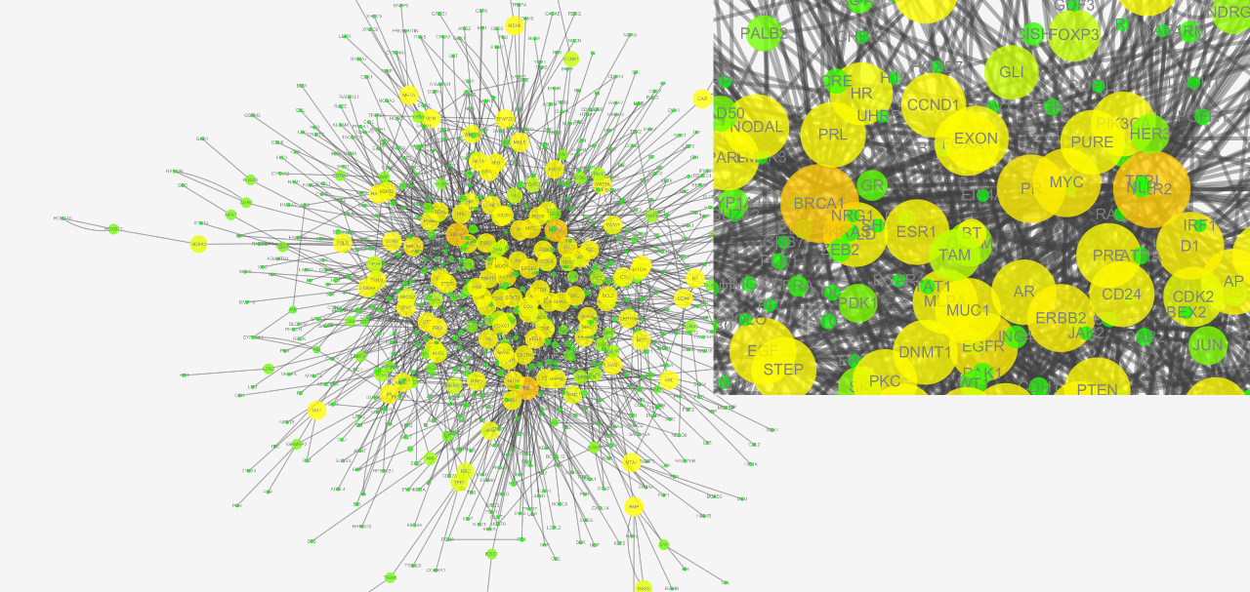
Fig. 6. Network of betweenness centrality analysis.
As for betweenness centrality, the higher the betweenness centrality, the more resources this node will control. The right part in Figure 5 is the distribution of betweenness centrality, the system can select the nodes whose betweenness centrality values are in the interval (0.2, 0.3), and ignore the other nodes which are not in this interval on the one hand, on the other hand, all the nodes can be ranked and the system chooses the top 10 gene entities.
The right part of Table 2 demonstrates the top 10 gene entities with highest ranking. Comparing with the top 10 gene of degree centrality, only HOX (homeobox gene) and SYK (protein-tyrosine kinase syk) these two gene entities are not included in degree centrality top 10 gene entities, the rest of the gene entities are the same as degree centrality even the gene entities positions in the ranking are almost consisted with the degree centrality. In other words, similar results can be obtained by different evaluation standards, this is also the reason why to weight the degree centrality and betweenness centrality for final analysis.

The result of weight analysis
The weight method can effectively utilize the information from the results analysis of degree centrality and betweenness centrality. The highest-ranked 15 gene entities are shown in Table 3.
There are two mistakes among the 15 extracted gene entities, as for gene PRO, on the one hand, gene entity named after PRO in fact has no connection with breast cancer, on the other hand, more often, PRO is not a gene entity in corpus, the mistake is caused by the name entity recognition module. The rest of gene entities almost are the combination results of degree and betweenness centrality, this further illustrates the rationality of the weighted analysis.
Table 3
Top 15 gene entities of weight method
Gene name | Weight | Relevant
BRCA1 | 0.6109 | YES
HER2 | 0.5803 | YES
MB | 0.5648 | NO
HOX | 0.5067 | YES
SYK | 0.5067 | YES
EGFR | 0.2814 | YES
ERBB2 | 0.2368 | YES
BRCA2 | 0.2298 | YES
D1 | 0.2151 | YES
MYC | 0.2120 | YES
PR | 0.1882 | YES
VEGF | 0.1665 | YES
EGF | 0.1617 | YES
PRO | 0.1497 | NO
SRC | 0.1410 | YES

Table 4
Top 10 gene entities of directed interaction
Gene name | Frequency | Relevant
BRCA1 | 364 | YES
HER2 | 229 | YES
BRCA2 | 180 | YES
ERBB2 | 64 | YES
EGFR | 54 | YES
SNP | 50 | YES
TP53 | 45 | YES
D1 | 43 | YES
EZH2 | 38 | YES
PTEN | 33 | YES

The result of the direct interaction
In the evaluation of results, the former analysis focuses on the interactions between gene entities. From another point of view to analyze the problem, breast cancer can be considered as an entity and the system can extract the direct interactions between gene entity and breast cancer. Selecting the top 10 gene entities which are sorted by the frequencies of gene entities. The top 10 gene entities are showed in Table 4.
All of the 10 gene entities are related to the breast cancer in fact, and the result is similar to the degree centrality analysis. Choosing frequency as a standard may be easily influenced by the corpus, the direct interaction result can be only considered as a reference result.

Conclusion and future work
Relation extraction can be the basic procedure of information integration, while gene disease relations play an important part in bio-information domain. In this work, a relation extraction method and a network analysis method were proposed to extract the most relevant gene entities to a specific disease.
The proposed approach was tested on LLL-challenge standard dataset and the errors were analyzed in particular to make an improvement in the future. In addition, the system was applied on PubMed corpus and finally construct the gene disease interaction network, through the analysis of network centralities, the system finally found the most relevant gene entities to breast cancer. In the future work, we will focus on the classification of extracted gene disease relations to extract more usable information.

Acknowledgements
This research has been partially supported by National Natural Science Foundation of China under Grant No.61203312 and the National High-Tech Research & Development Program of China 863 Program under Grant No.2012AA011103 and the Scientific Research Foundation for the Returned Overseas Chinese Scholars, State Education Ministry, and Key Science and Technology Program of Anhui Province, under Grant No.1206c0805039.
References
- J. Saric, L.J. Jensen and I. Rojas, Large-scale extraction of gene regulation for model organisms in an ontological context, In silico biology 5 (2005), 21-32.
- R. Feldman, Y. Regev and M. Gorodetsky, A modular information extraction system, Intelligent Data Analysis 12 (2008), 51-71.
- J. Ding, D. Berleant, D. Nettleton and E. Wurtele, Mining MEDLINE: abstracts, sentences, or phrases, Proceedings of the pacific symposium on Biocomputing 7 (2002), 326-337.
- A. Zanzoni, L. Montecchi-Palazzi, M. Quondam, G. Ausiello, M. Helmer-Citterich and G. Cesareni, MINT: a Molecular INTeraction database, FEBS letters 513 (2002), 135-140.
- S. Kerrien, B. Aranda and L. Breuza, The IntAct molecular interaction database in 2012, Nucleic acids research 40 (2012), 841-846.
- G.D. Bader, D. Betel and C.W.V. Hogue, BIND: the biomolecular interaction network database, Nucleic acids research, 31 (2003), 248-250.
- E. Buyko, E. Beisswanger and U. Hahn, Testing different ACE-style feature sets for the extraction of gene regulation relations from MEDLINE abstracts, Proceedings of the 3rd International Symposium on Semantic Mining in Biomedicine (2008), 21-28.
- A. Yakushiji, Y. Miyao, Y. Tateisi and J. Tsujii, Biomedical information extraction with predicate-argument structure patterns, Proceedings of the first International Symposium on Semantic Mining in Biomedicine (2005).
- K. Yoshikawa, S. Riedel, T. Hirao, M. Asahara and Y. Matsumto, Coreference based event-argument relation extraction on biomedical text, J. Biomedical Semantics 2 (2011).
- Z. GuoDong, S. Jian, Z. Jie and Z. Ming, Exploring various knowledge in relation extraction, Proceedings of the 43rd annual meeting on association for computational linguistics. Association for Computational Linguistics (2005), 427-434.
- G. Erkan, A. Özgür and D.R. Radev, Semi-supervised classification for extracting protein interaction sentences using dependency parsing, EMNLP-CoNLL 7 (2007), 228-237.
- Z. Suxiang, W. Juan, W. Xiaojie and L. Lei, Automatic entity relation extraction based on maximum entropy, Intelligent Systems Design and Applications, 2006. ISDA'06. Sixth International Conference on. IEEE 1 (2006), 540-544.
- A.Airola, S.Pyysalo, J. Björne, T. Pahikkala, F. Ginter and T. Salakoski, All-paths graph kernel for protein-protein interaction extraction with evaluation of cross-corpus learning, BMC bioinformatics 9 (2008).
- K. Fundel, R. Küffner and R. Zimmer, RelEx—Relation extraction using dependency parse trees, Bioinformatics 23 (2007), 365-371.
- H.Y. Kao, Y.T. Tang and J.F. Wang, Evolutional dependency parse trees for biological relation extraction, Bioinformatics and Bioengineering (BIBE), 2011 IEEE 11th International Conference on. IEEE (2011), 167-174.
- J. Björne, J. Heimonen, F. Ginter, A. Airola, T. Pahikkala and T. Salakoski, extracting contextualized complex biological events with rich graph‐based feature sets, Computational Intelligence 27 (2011), 541-557.
- M.C. De Marneffe, B. MacCartney and C.D. Manning, Generating typed dependency parses from phrase structure parses, In Proceedings of LREC 6 (2006), 449-454.
- D. Klein, and C.D. Manning, Accurate unlexicalized parsing, Proceedings of the 41st Annual Meeting on Association for Computational Linguistics. Association for Computational Linguistics 1 (2003), 423-430.
- D. Klein, and C.D. Manning, Fast exact inference with a factored model for natural language parsing, Advances in neural information processing systems (2002), 3-10.
- R. Socher, J. Bauer, C.D. Manning and A.Y. Ng, Parsing with compositional vector grammars, In Proceedings of the ACL conference (2013).
- C.D. Manning, Foundations of statistical natural language processing, MIT press (1999).
- A. Lluch, P. Eroles and J.A. Perez-Fidalgo, Emerging EGFR antagonists for breast cancer, Expert opinion on emerging drugs 0 (2014), 1-17.
- G.S. Omenn, Y. Guan and R. Menon, A New Class of Protein Cancer Biomarker Candidates: Differentially-Expressed Splice Variants of ERBB2 (HER2/neu) and ERBB1 (EGFR) in Breast Cancer Cell Lines, Journal of proteomics (2014).
- J. Chung, H. Noh and K.H. Park, Longer Survival in Patients with Breast Cancer with Cyclin D1 Over-Expression after Tumor Recurrence: Longer, but Occupied with Disease, Journal of breast cancer 17 (2014), 47-53.

*Corresponding author. E-mail: quanchqin@hfut.edu.cn.

